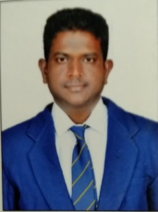

**STAFF PROFILE**

|  |  |  |  |
| --- | --- | --- | --- |
| Name | : | **Dr.RAMESWARAM SATYA PRAKASH** | |
| Designation | : | **Assistant Professor** | |
| Qualification | : | **B.A.,B.P.Ed.,M.P.Ed.,M.Phil.,Ph.D** | |
| Experience | : | **07 Years** | |
| **Sports Achievement** | | | |
| Represented State Level Table Tennis Tournament 2017-2018 | | | |
| Represented National Level Table Tennis Tournament 2014-2015 | | | |
| **Publication** | | | |
| **Particulars** | **International Level** | | **National Level** |
| Journals | 02 | | 01 |
| Conference | 03 | | xx |